Отчет по лабораторной работе №6
Цель: научить использовать преобразование типов
Задание 1:
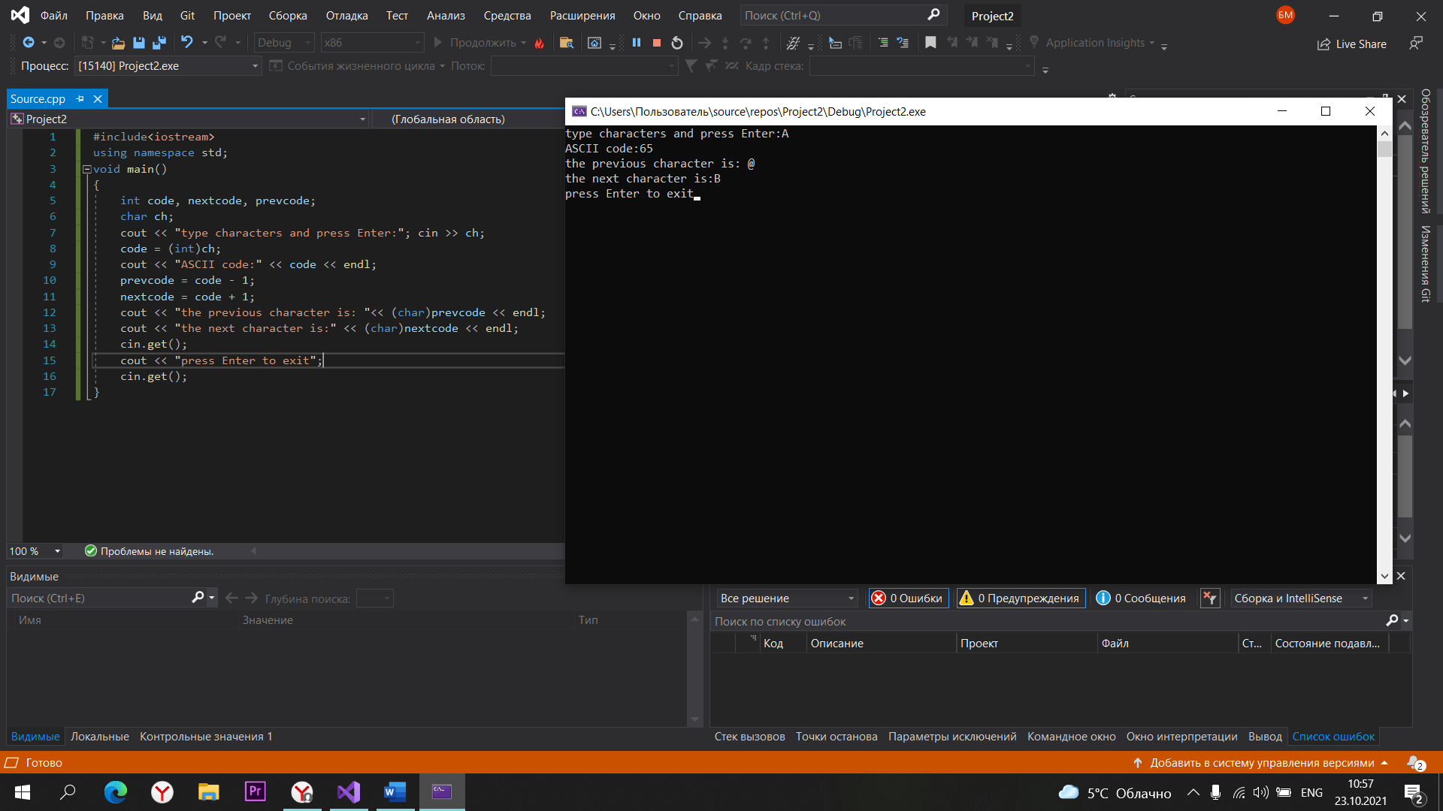
Сode задание 1:
#include<iostream>
using namespace std;
void main()
{
int code, nextcode, prevcode;
char ch;
cout << "type characters and press Enter:"; cin >> ch;
code = (int)ch;
cout << "ASCII code:" << code << endl;
prevcode = code - 1;
nextcode = code + 1;
cout << "the previous character is: "<< (char)prevcode << endl;
cout << "the next character is:" << (char)nextcode << endl;
cin.get();
cout << "press Enter to exit";
cin.get();
}
Задание2:
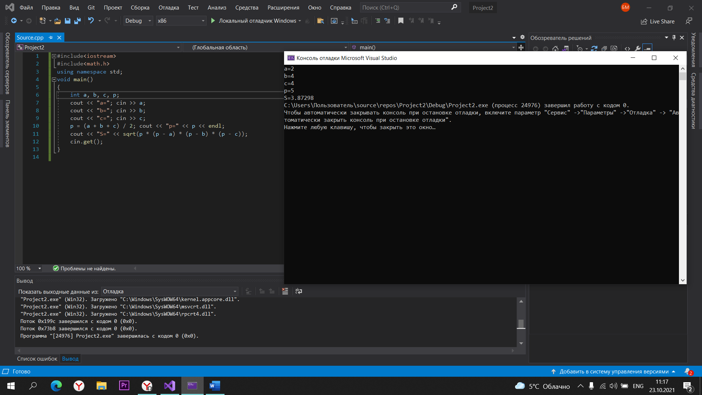

Code задание 2:
#include<iostream>
#include<math.h>
using namespace std;
void main()
{
int a, b, c, p;
cout << "a="; cin >> a;
cout << "b="; cin >> b;
cout << "c="; cin >> c;
p = (a + b + c) / 2; cout << "p=" << p << endl;
cout << "S=" << sqrt(p * (p - a) * (p - b) * (p - c));
cin.get();
}

